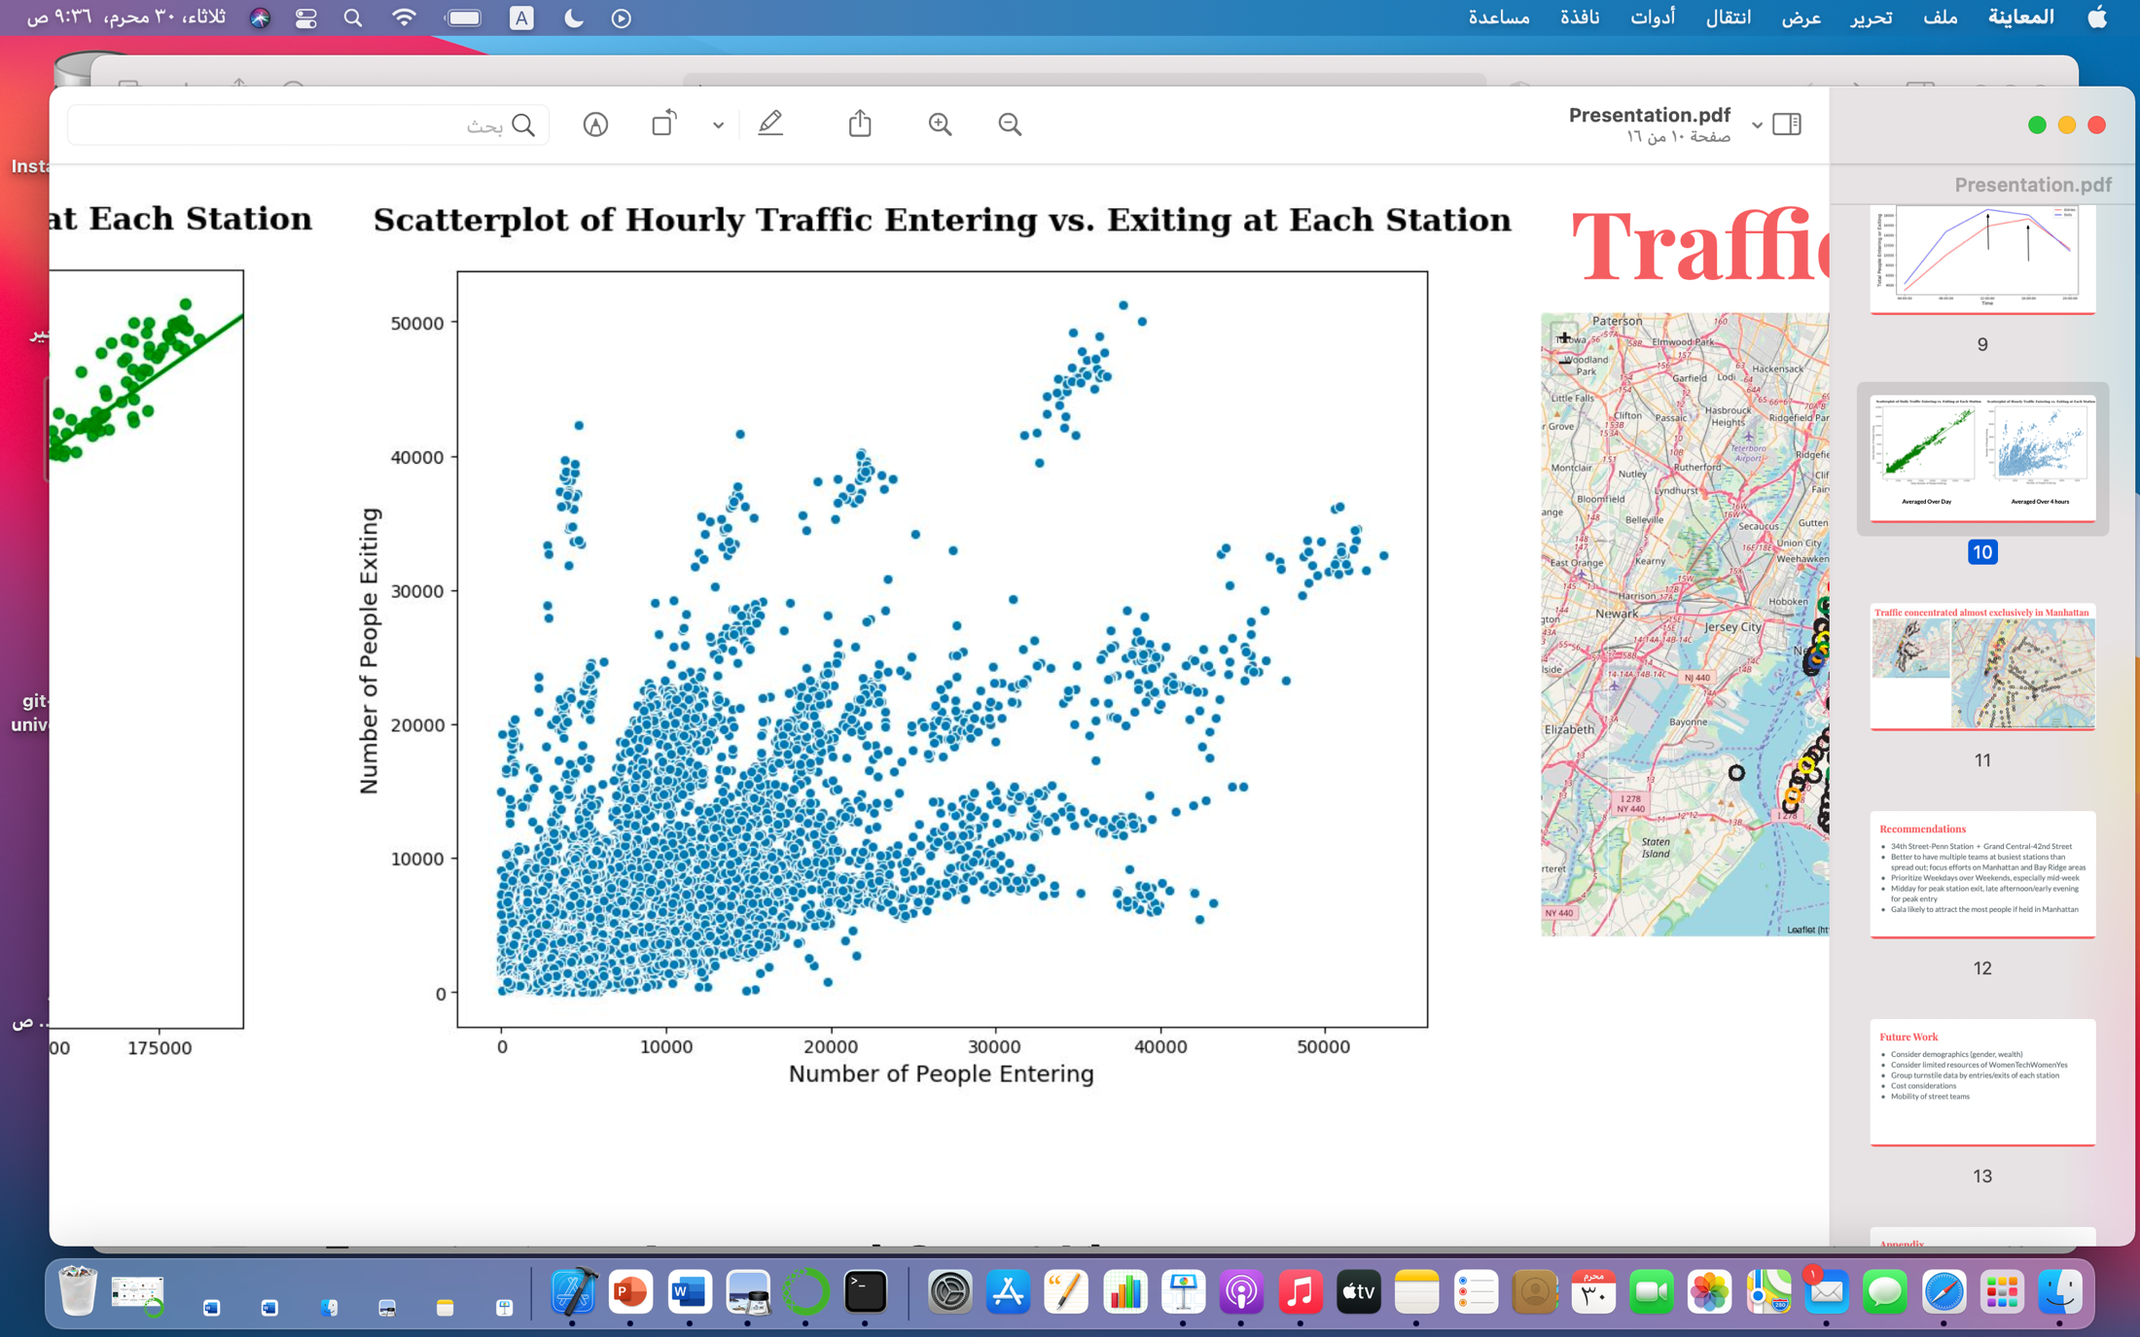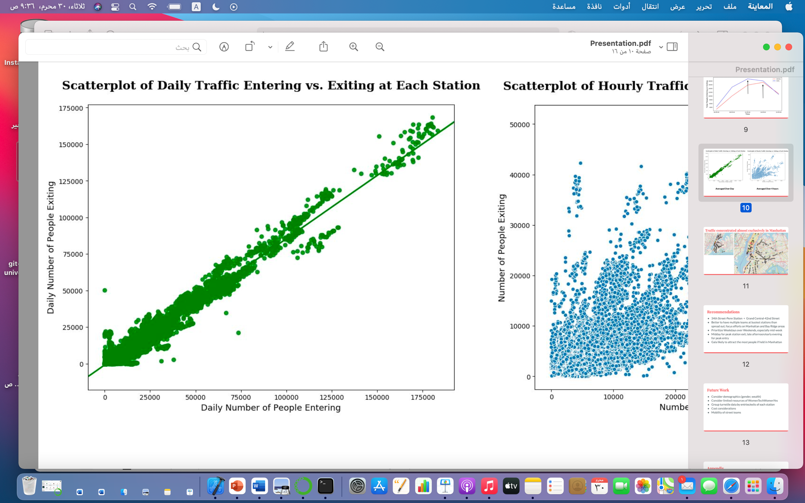

**Scatterplot of Hourly Traffic Entering vs. Exiting at Each Station**

**Scatterplot of Daily Traffic Entering vs. Exiting at Each Station**

**MVP**